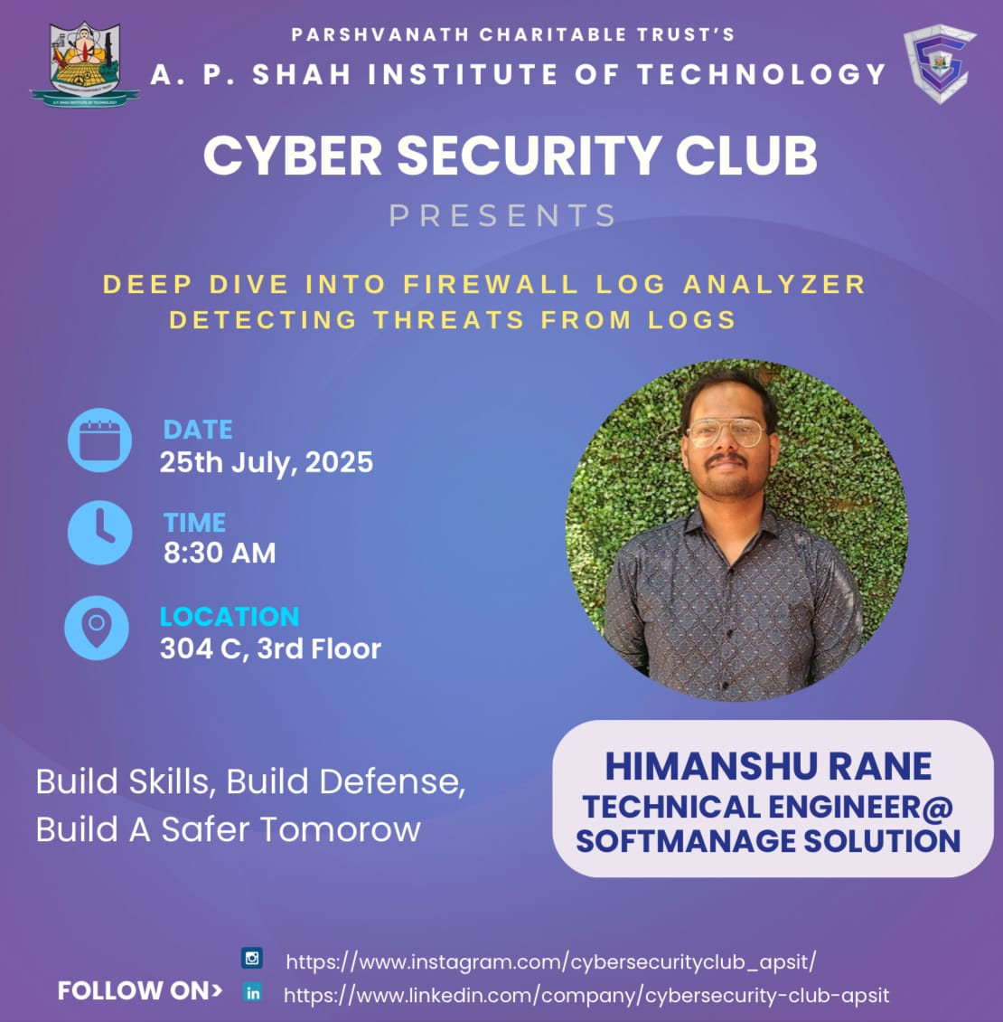

Session: Expert Talk (DEEP DIVE INTO FIREWALL LOG ANALYZER: DETECTING THREATS FROM LOGS.)

Name of College: A. P. Shah Institute of Technology, Kasarvadavali, Ghodbunder Road, Thane – 400615

Date: 25/07/2025
Venue: 304-C
Participants: 40
Targeted Audience: Students Interested in Cybersecurity learning domain from IT, CS, DS, AIML Department.

Speaker: Himanshu Rane(alumna)

Faculty Accompanied:

Prof. Sneha Dalvi

Prof. Randeep Kaur Kahlon

Prof. Manjusha Kashilkar.

Organizers:
Cybersecurity Club, A. P. Shah Institute of Technology

Aim of Event: Himanshu Rane an alumni of APSIT gave insights about Firewall Log Analyzer.

The event featured Himanshu Rane, a distinguished speaker known for his expertise in cybersecurity. Himanshu led an insightful session on "Deep Dive into Firewall Log Analyzer: Detecting Threats from Logs."
Himanshu embarked on a comprehensive exploration of firewall log analysis, focusing on its importance for threat detection. He discussed various types of firewall logs and how to interpret their key indicators. The session included a hands-on segment demonstrating the practical applications of ManageEngine Firewall Analyzer. He showed how this tool centralizes log collection from diverse firewall vendors, parses raw log data into an easily readable format, and analyzes it in real-time. This allows for the identification of suspicious patterns, anomalies, and potential attack vectors that often go unnoticed. Specifically, ManageEngine Firewall Analyzer helps pinpoint security attacks, detect viruses, track insider threats, monitor bandwidth usage, and perform forensic analysis to trace the root cause of security incidents. It also assists in optimizing firewall rules and ensuring compliance through automated reports.
Students left the event energized and inspired. They valued Himanshu's expertise, expressing positive feedback and a clear understanding of firewall log analysis as a path to their future careers.

SOME PHOTOS OF THE EVENT:

